**Capstone Projects**

You have been Hired Sr. DevOps Engineer in Abode Software. They want to implement DevOpsLifecycle in their company. You have been asked to implement this lifecycle as fast as possible. Abode Software is a product-based company, their product is available on this GitHub link.

<https://github.com/hshar/website.git>

Following are the specifications of the lifecycle:

1. Install the necessary software on the machines using a configuration management tool.

Ans: First we will made the 1 master and 1 node machine for this.

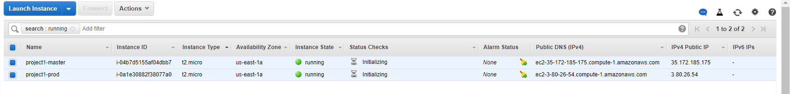

And then we need to install Ansible and connect prod node to master using ssh so that we can run the ansible playbook to install required software.

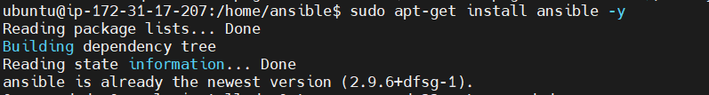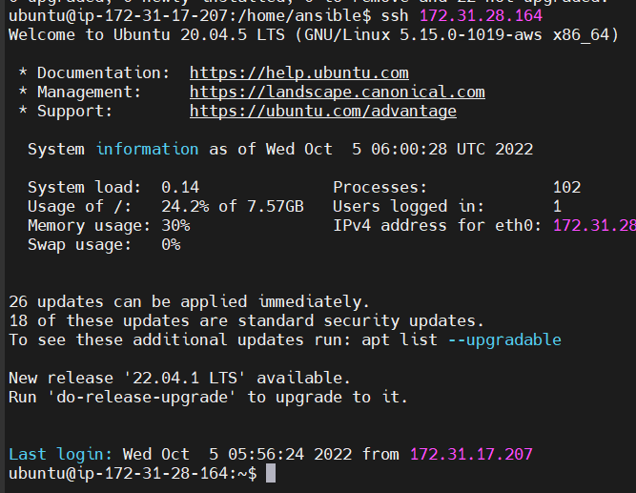

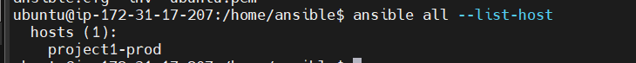

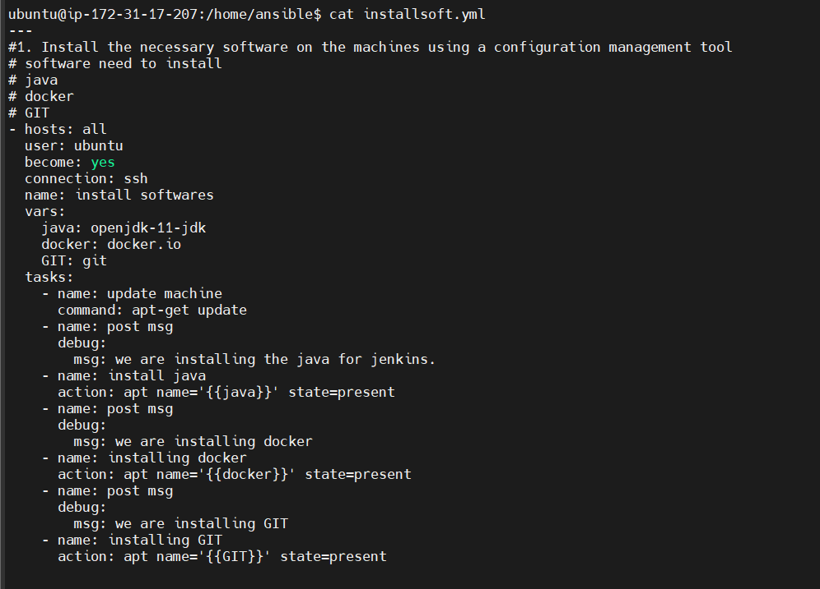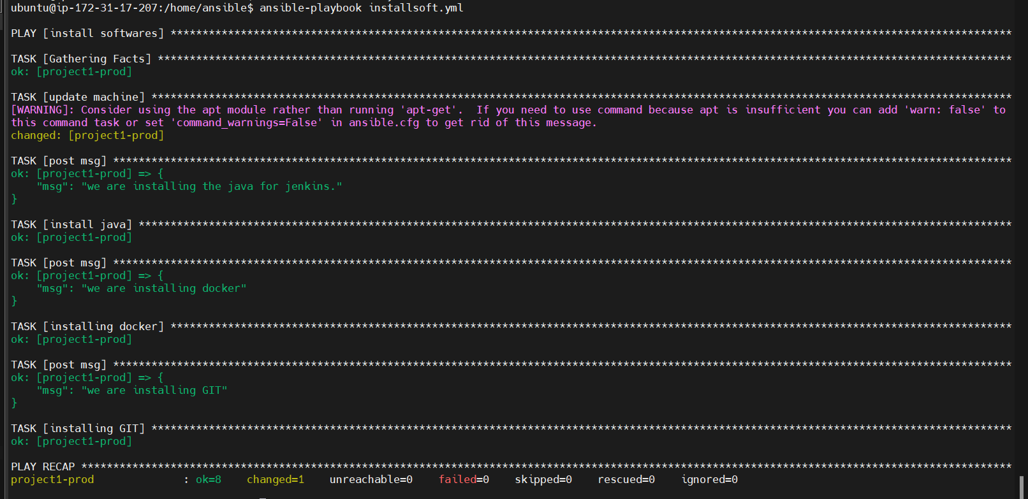

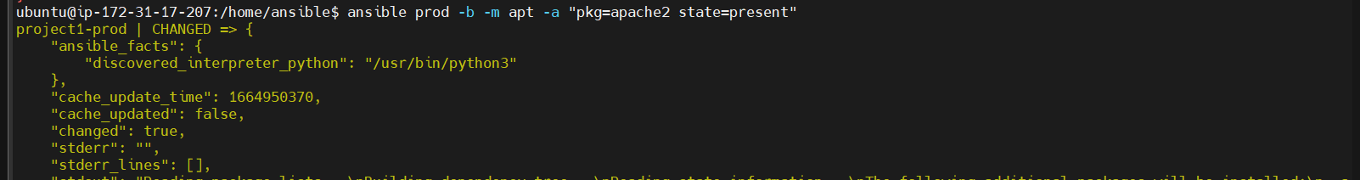

2. Git Workflow has to be implemented

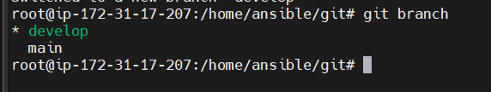

1. Code Build should automatically be triggered once commit is made to master branch or develop branch.

If commit is made to master branch, test and push to prod

If commit is made to develop branch, just test the product, do not push to prod

Ans: now we add node.

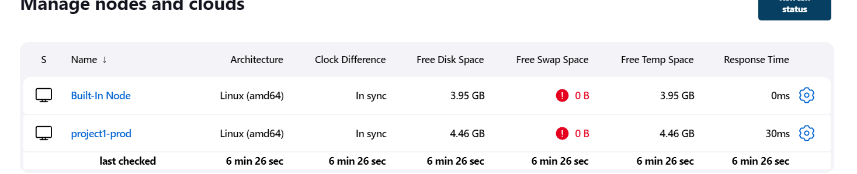

Then will create the build job.



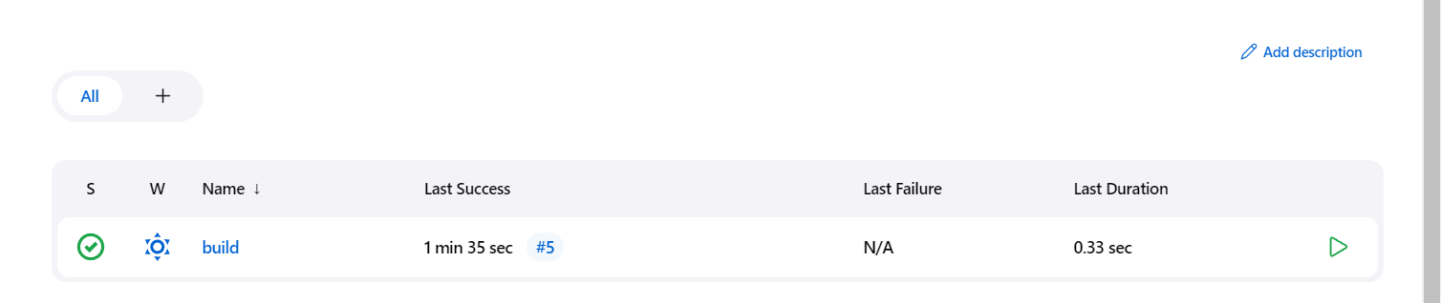

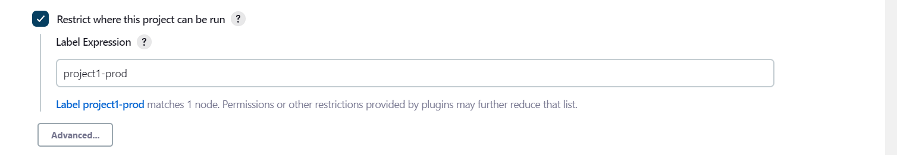

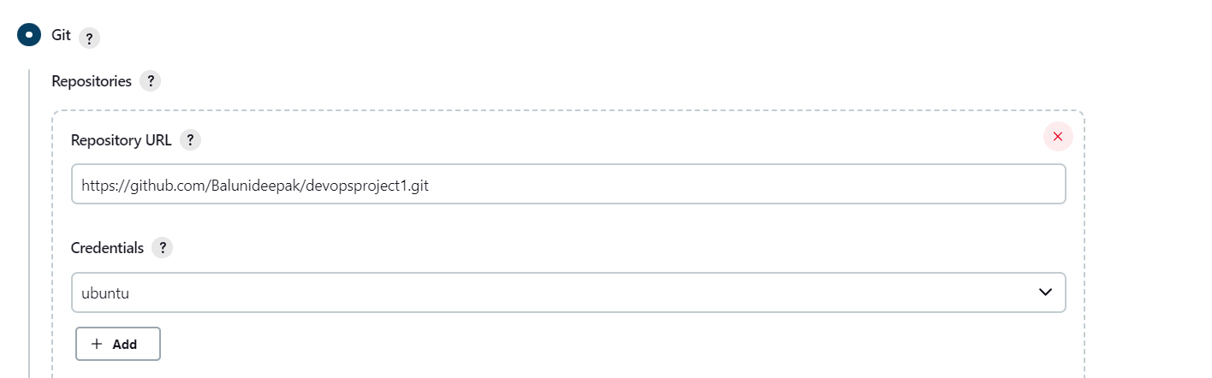

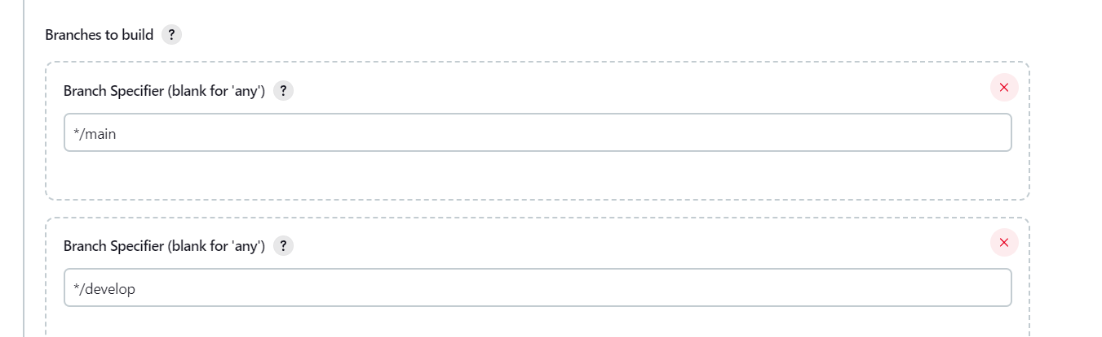

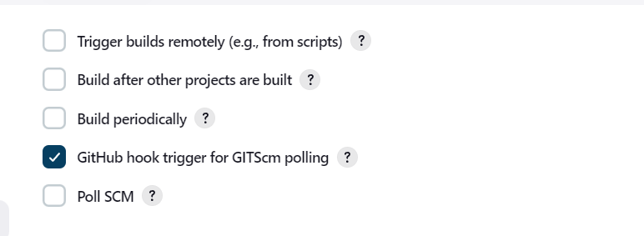

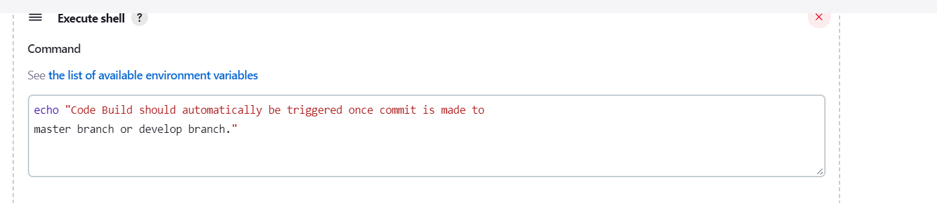

Result: 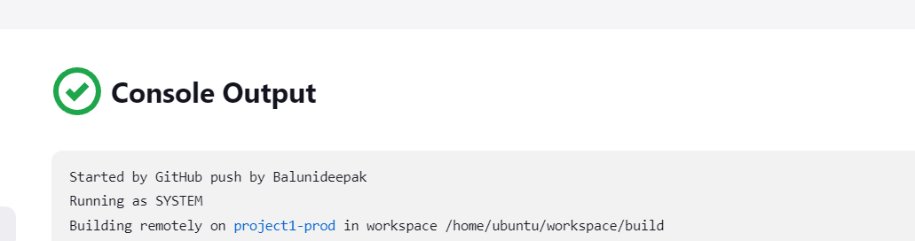

**If commit is made to master branch, test and push to prod**

We will create a job name prod and will do the configuration.

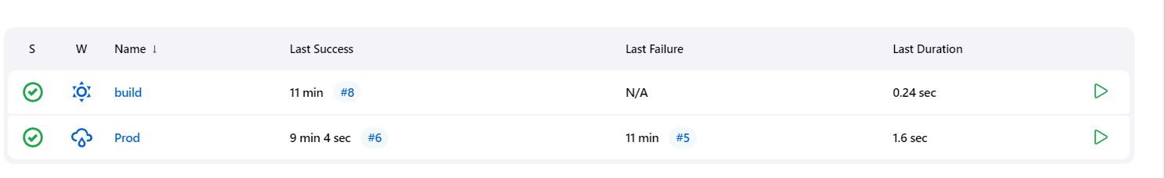

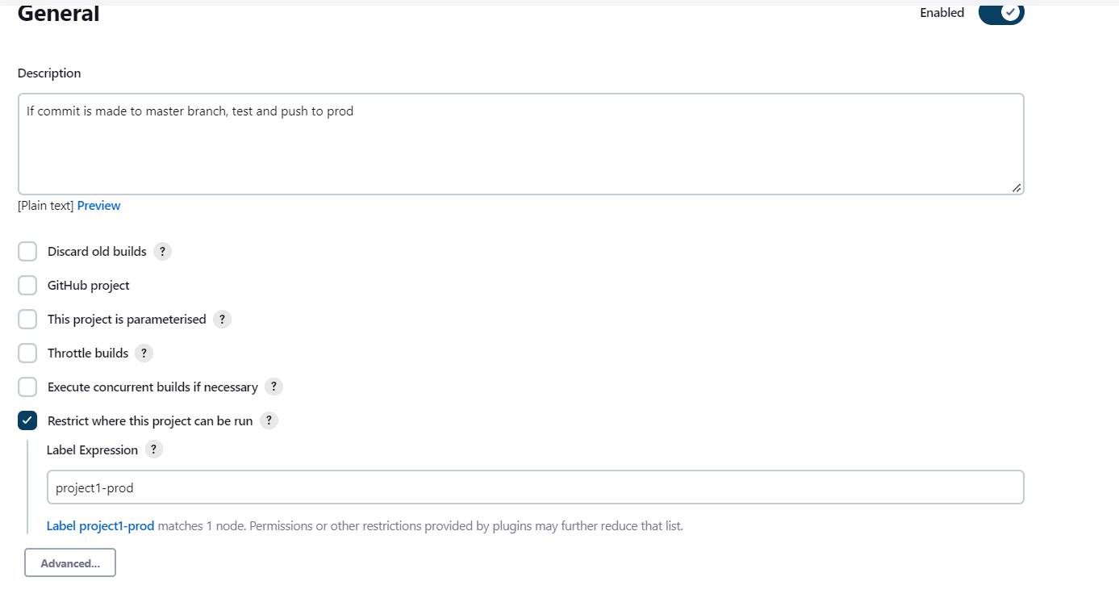

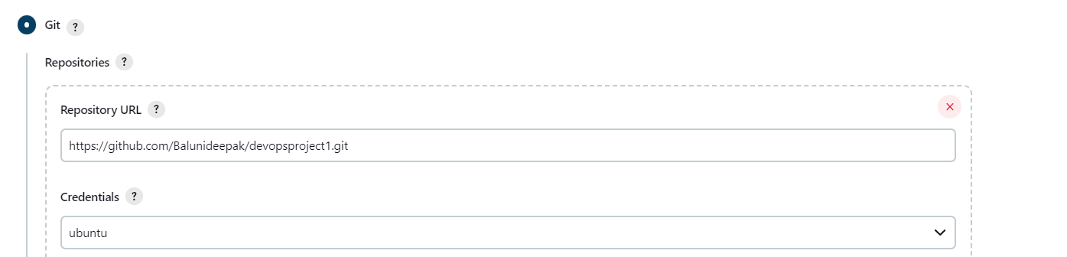

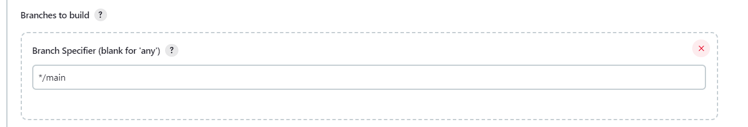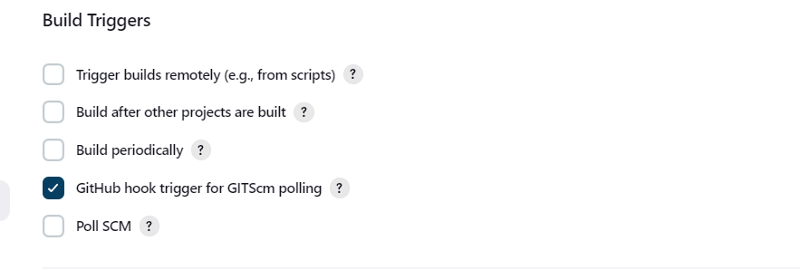

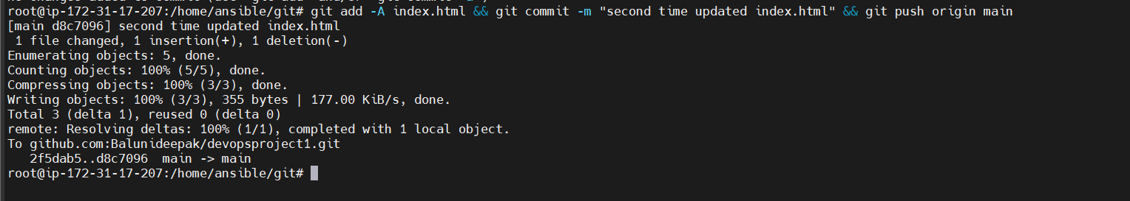

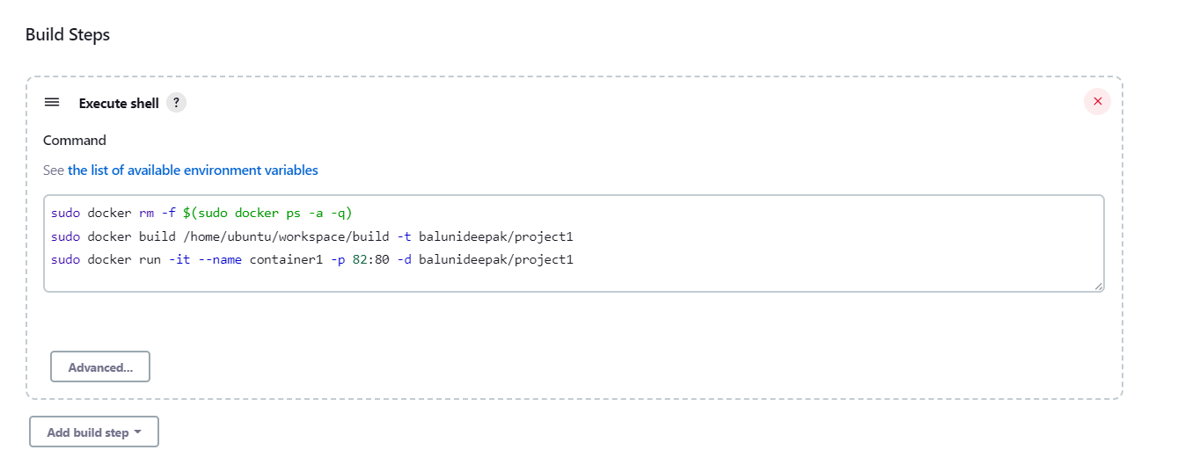

**Result**

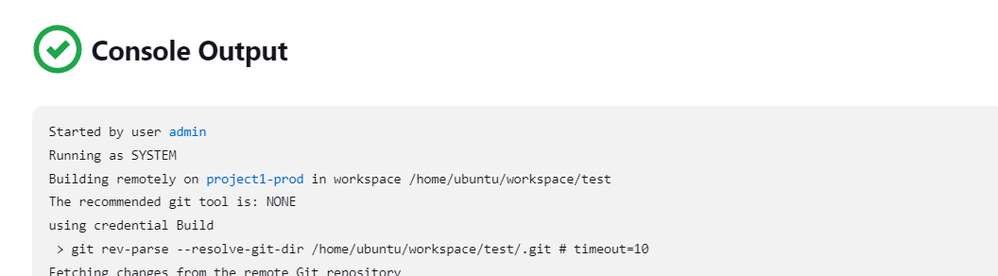

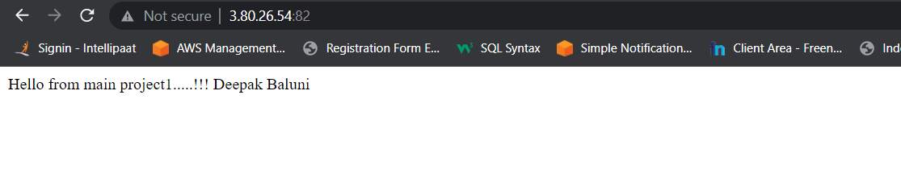

**If commit is made to develop branch, just test the product, do not push to prod**

**Ans:**  For this we need to create another job name test in this we only need to config that if any push made to develop branch it will only test.

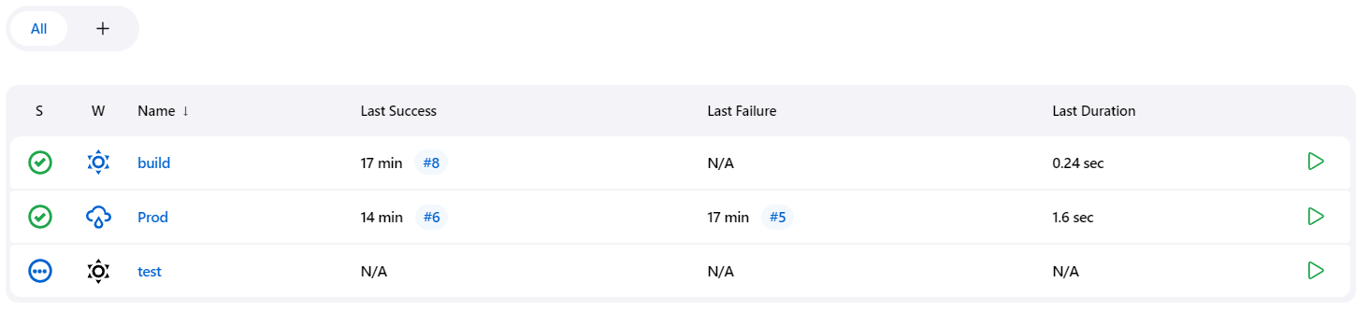

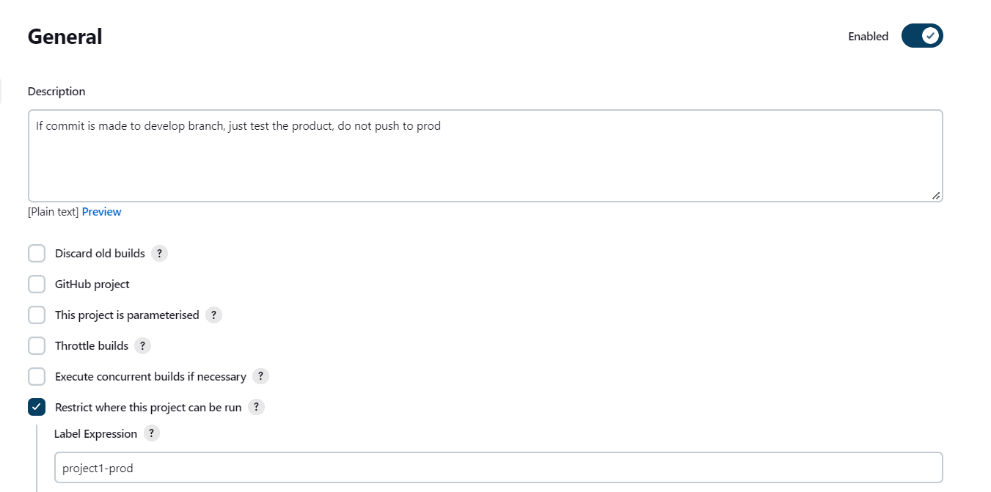

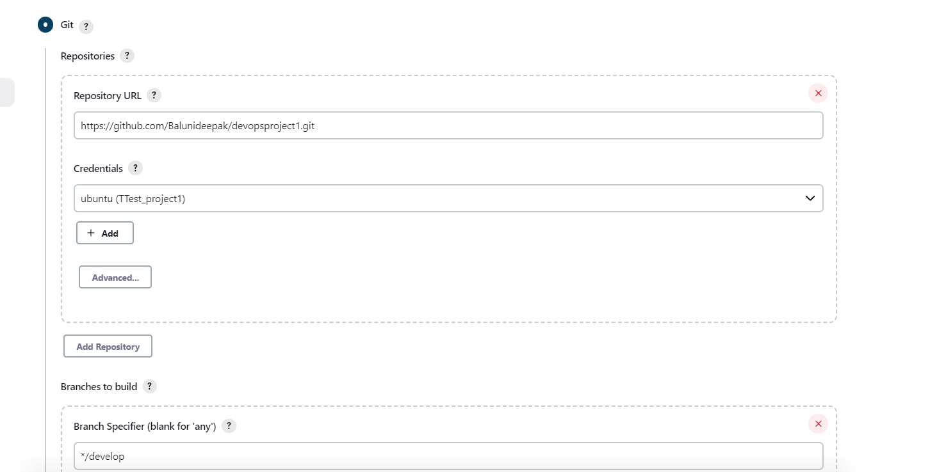

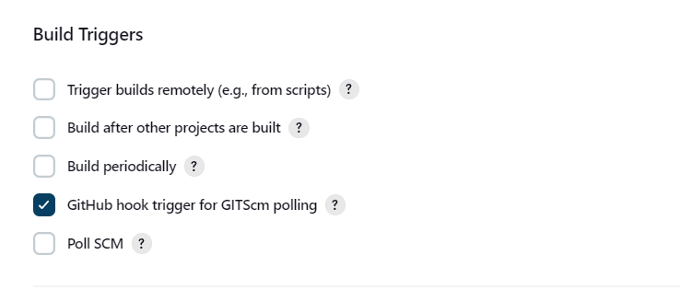  
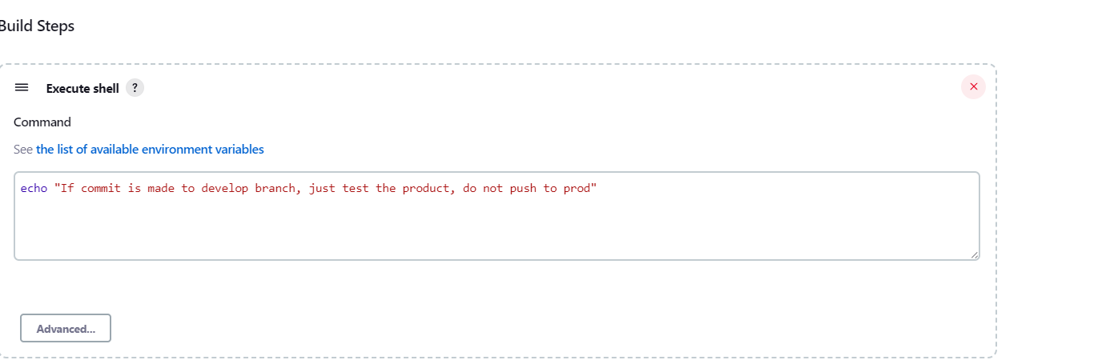

**Result:**

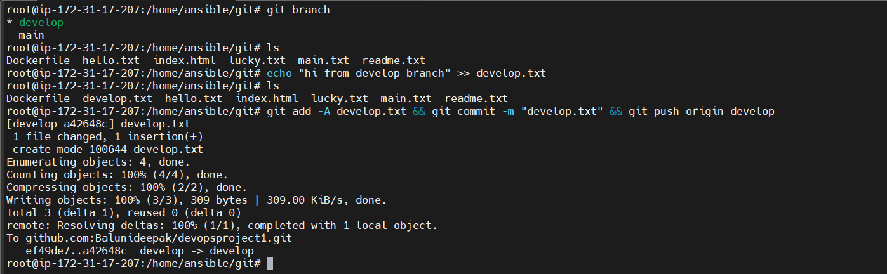

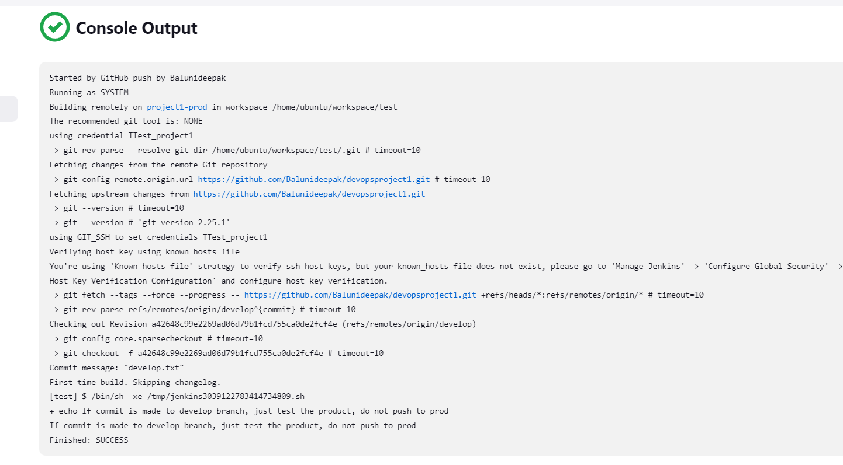

1. **The Code should be containerized with the help of a Dockerfile. The Dockerfile should bebuilt every time there is a push to Git-Hub.**

**Use the following pre-built container for your application: hshar/webapp**

**The code should reside in '/var/www/html'**

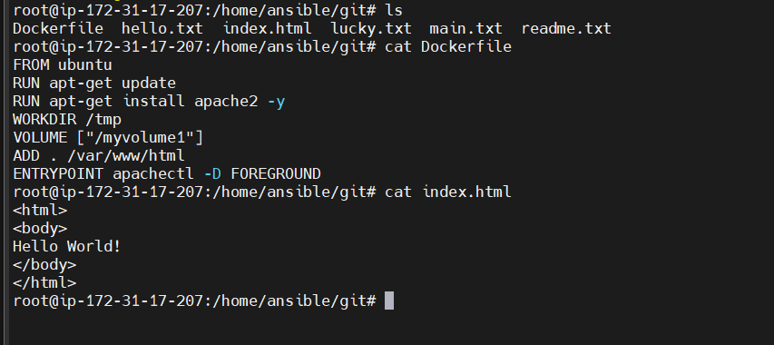

**In order to The Dockerfile should bebuilt every time there is a push to Git-Hub**

**We need to add command docker rm –f $(sudo docker ps -a -q) so that in every push the docker will create the docker file again.**



1. The above tasks should be defined in a Jenkins Pipeline, with the following jobs:

Job1 : build

Job2: test

Job3 : prod

**Ans:**  For pipeline we will go to dashboard and click on manage Jenkins.

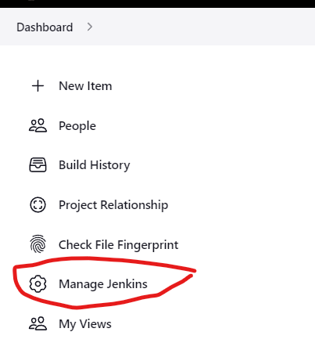

Then click on manage Jenkins.

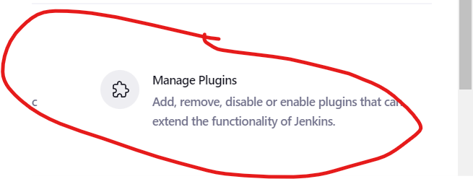

Then click on available and search for pipeline.

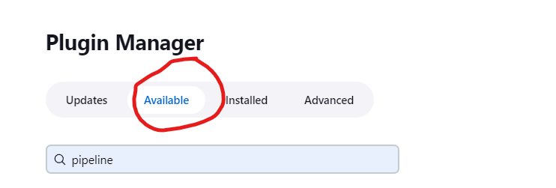

Then click on Build pipeline and click on Install without restart.

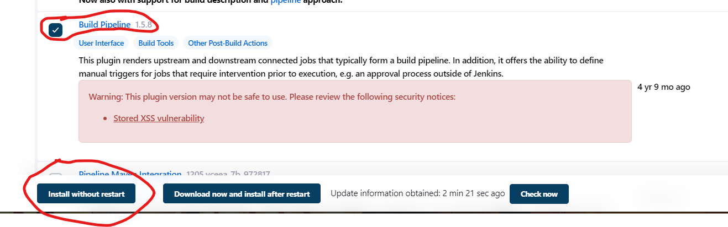

After that you will get this page.

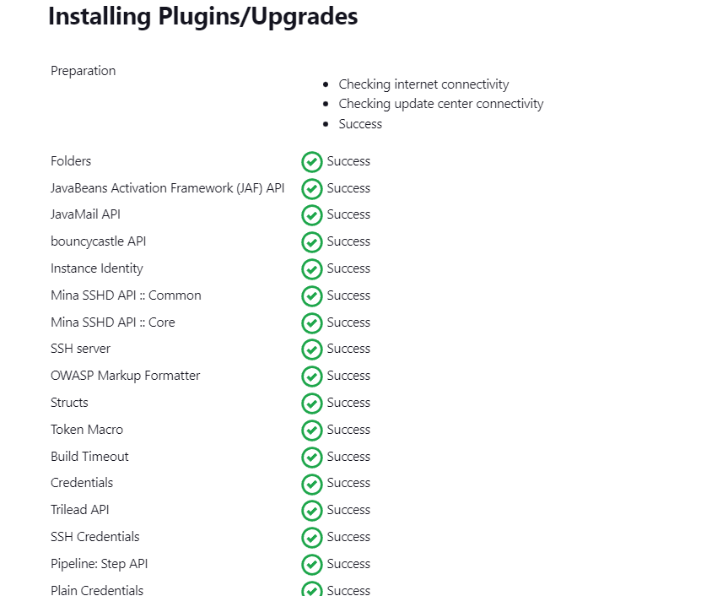

Once every everything is marked as success close this page and click on this + sign.

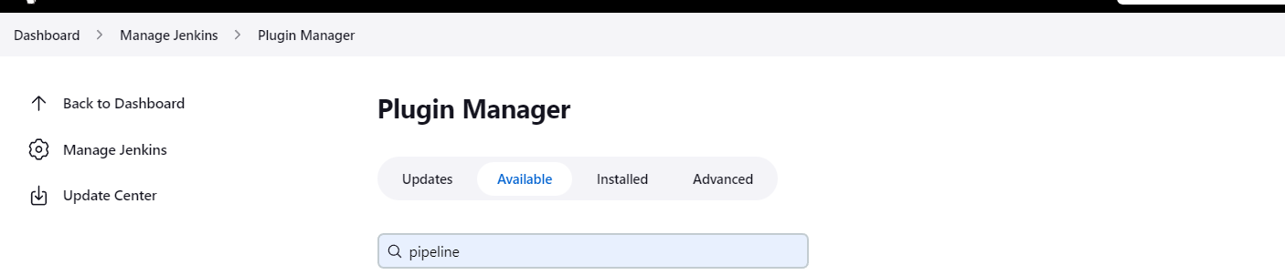

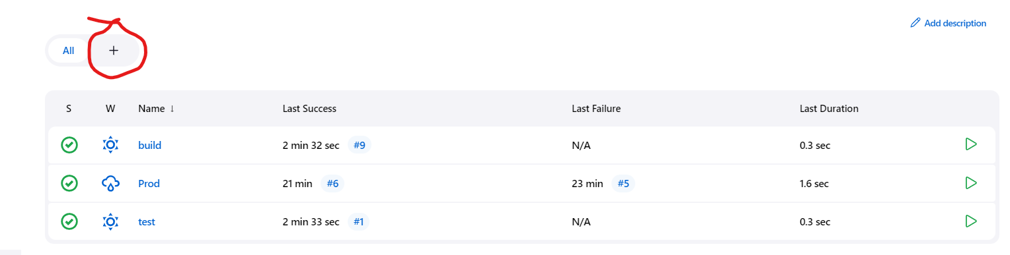

After that you need to give name for pipeline and click on build pipeline view and click on create.

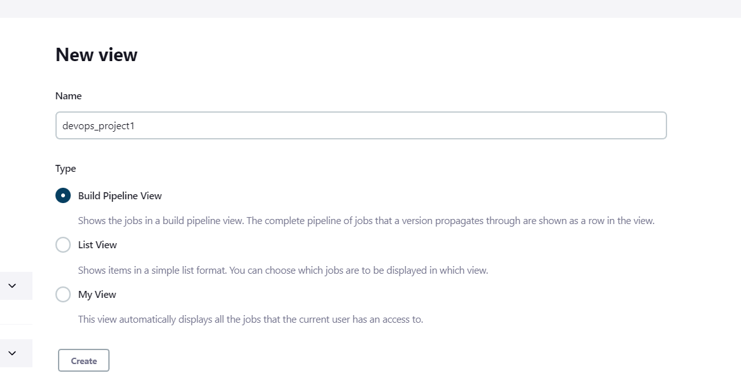

You will get this page keep everything in default and click on ok.

